Myrosta
Your ED roster — on every device
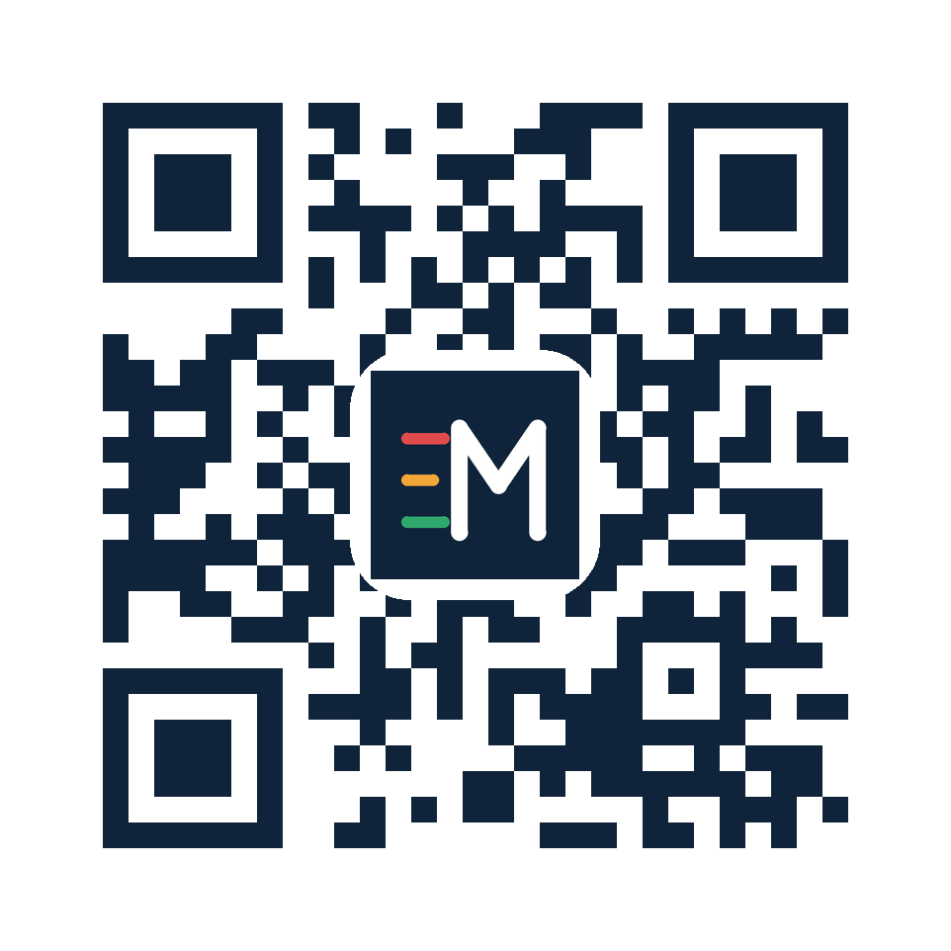
Scan to open Myrosta
myrosta.com.au
Sign in on your phone
- Open myrosta.com.au and tap Sign in.
- Choose Mobile (SMS), enter your mobile, tap Send code. (Prefer email? Tap Email.)
- Type the 6-digit code you receive — you’re in. You stay signed in, so it’s a one-time setup.
- Optional: Add to Home Screen (iPhone: Share menu · Android: ⋮ menu) so it opens like an app.
Sign in on a computer
- Go to myrosta.com.au in Chrome, Edge or Safari and sign in the same way (a code by SMS or email).
- In Chrome/Edge, click the install icon in the address bar to keep it as a desktop app — it stays in sync with your phone.
What you can do
- See your own shifts (list or calendar) and add them to your phone calendar with reminders.
- Pick your shifts when a round opens — collision-proof and quota-fair.
- Request leave or a swap in a tap.
No code arriving? Check junk/spam, wait a moment and tap Resend, and make sure your roster admin has your correct mobile/email on file. If your hospital email blocks external mail, just use Mobile (SMS).

